**College of Saint Mary**

**Lesson Plan Format with Evidence of Student Learning Analysis**

|  |  |  |  |  |
| --- | --- | --- | --- | --- |
| **LESSON/ACTIVITY INFORMATION** | | | | |
| **Title: Sentence Surgery** | | | | |
| **Your name:** Kelsey Whipple | **Age or Grade Level:** 4th Grade | | **Integrated Disciplines/Subjects:** Language Arts | **Time frame for Lesson:** 30 Minutes |
| **STANDARDS, OBJECTIVES, ASSESSMENTS & MATERIALS** | | | | |
| LA 4.1.5.a Apply knowledge of word structure elements, known words, and word patterns to determine meaning (e.g., plurals, possessives, parts of speech, affixes, base and root words).  LA 4.2.1.d Compose paragraphs with grammatically correct sentences of varying length, complexity, and type  LA 4.2.1.h Proofread and edit writing recursively for format and conventions of standard English (e.g., spelling, capitalization, grammar, punctuation, syntax, semantics). | | | | |
| **Objectives:**  Given instruction, the students will be able to classify words into parts of speech categories accurately 4 out of 5 times.  Given instruction on sentence structure, the students will be able create sentences with each of the parts of a sentence accurately 4 out of 5 times.  Given instruction on editing, the students will be able to analyze their work for correct spelling, capitalization, and punctuation and make accurate changes 4 out of 5 times. | | | | |
| **Assessment:** *The teacher will use an answer key to check the student’s corrected sentences for accuracy.* | | | | |
| **Materials:** *Sentence Strips, Editing Markers, Paper, Pencils, and COPS Anchor Chart* | | | | |
| **LESSON PROCEDURES** | | | | |
| **Anticipatory Set:** *Put sentences and sentence fragments on the board one at a time. Ask students what’s wrong or weird about the sentence. Ask what needs to be added or changed to correct the sentence.*  *Introduce the COPS Anchor Chart.* | | | | |
| **Input/Modeling/Guided Practice/Check for Understanding:** *The following section must include all of the steps the teacher needs to do in order to carry out the lesson and must also include all of the responses and activities that students will be expected to do.*  ***DETAILS*** *are important here in order to demonstrate your thinking of what this will look like in the classroom. Write this section so that the lesson could be easily replicated.* | | | | |
| **Teacher will do:**  - Lead the anticipatory set. Show one sentence on the Elmo at a time. Ask the students what is wrong with the sentence. Go over each sentence.  - Introduce the COPS Anchor Chart. Discuss the importance of editing when we are writing.  - Introduce the sentence surgery activity. Tell the student that he will be editing sentence strips.  - Have the sentences lying around the room. Tell the student that he will go around to each sentence and use a dry-erase board marker to circle the errors in the sentences. – Instruct him that after he circles the errors, he must rewrite the sentence correctly on his paper. Direct him to then move to the next one.  - Instruct the student to turn in his paper when he is done with all of the sentences.  - Go over each of the sentences with the student.  - Walk around as the student works.  - Ask any questions that the student may have.  - Hand out the 3-2-1 activity about writing sentences. Collect this from the student when he is done. | | **Student will do:**  - As the teacher puts each sentence on the Elmo, discuss what is wrong with each sentence and how to fix it.  - Look over the COPS Anchor Chart.  - Answer questions about why editing our writing is important.  - Listen to the directions for the sentence surgery activity.  - Pick a sentence to start at for the activity.  - Use a dry-erase board marker to circle the errors in the sentence. Rewrite the sentences correctly on your paper. Then move onto the next sentence.  - When finished, turn in your paper to the teacher.  - Go over each sentence with the teacher.  - Ask questions when needed.  - Complete the 3-2-1 activity about writing sentences.  - Turn in the 3-2-1 activity to the teacher. Make sure your name is on it. | | |
| **Closure:** *3-2-1 Activity*  *3 Things you learned about sentences this week*  *2 Things you still want to learn about sentences*  *1 Your favorite thing about sentences* | | | | |
| **Differentiation:**  *The student falls asleep throughout the day. When he falls asleep he will be prompted to wake up and then will get up to walk around before going back to work. The student will also be given a medicine ball to sit on while he works to keep him moving.* | | | | |
| **References:**  [*http://www.3rdgradethoughts.com/2012/10/writers-workshop-revising-arms-editing.html#.UXpw5qKG2Ah*](http://www.3rdgradethoughts.com/2012/10/writers-workshop-revising-arms-editing.html%23.UXpw5qKG2Ah) | | | | |
| **LESSON CONTENT AND STRATEGIES**  *Review all of the previous sections of your lesson plan* ***and***  *complete items in the following section prior to teaching your lesson.* | | | | |
| **Content Knowledge:**  *It is important for Student P to learn editing and proofreading skills because they are a part of the writing process. When students edit and proofread, they notice errors they made and can correct and learn from their mistakes. For Student P, noticing capitalization, punctuation, and spelling errors is a top priority because most of the mistakes he makes when writing relate to those three things.*  **Teaching Methods/Strategies:**  *The teaching method used in this lesson is one on one instruction. I think this is effective because the student is below grade level in writing and spelling and will benefit from the one on one time. We will focus on the skills he is struggling on at his pace and this should help him to learn the necessary topics and practice the skills.* | | | | |
| **EVIDENCE OF STUDENT LEARNING ANALYSIS**  *This activity was a struggle for Student P at first because he was only thinking about capital letters and punctuation marks as being errors. However, when I asked him about misspelled words, he would reread the sentences and usually notice the extra errors. The errors Student P made were not looking at the sentence strips when copying the corrected sentences onto this paper. He would get distracted and would have to erase what he had written and try again.*  *I was given a small time window to work with Student P on this day, so we did not do the closure activity. Instead, we went over each sentence strips and what he had rewritten. We talked about how it will be extremely important for him to keep using capitalization and punctuation in his writing.* | | | | |

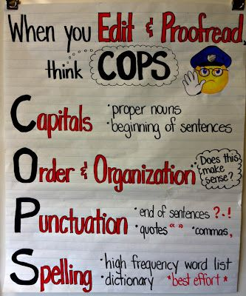

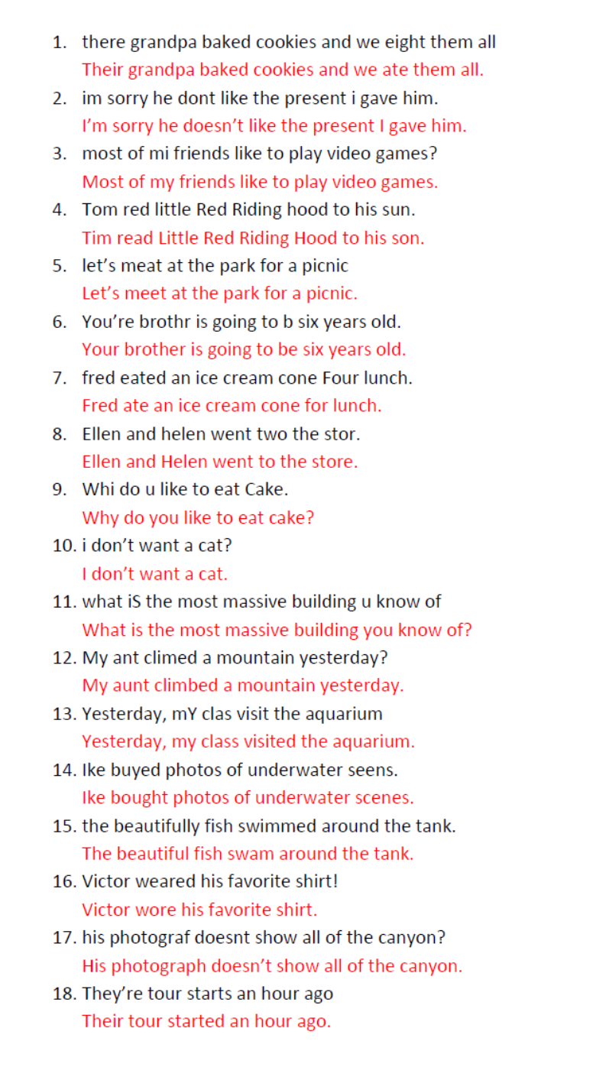



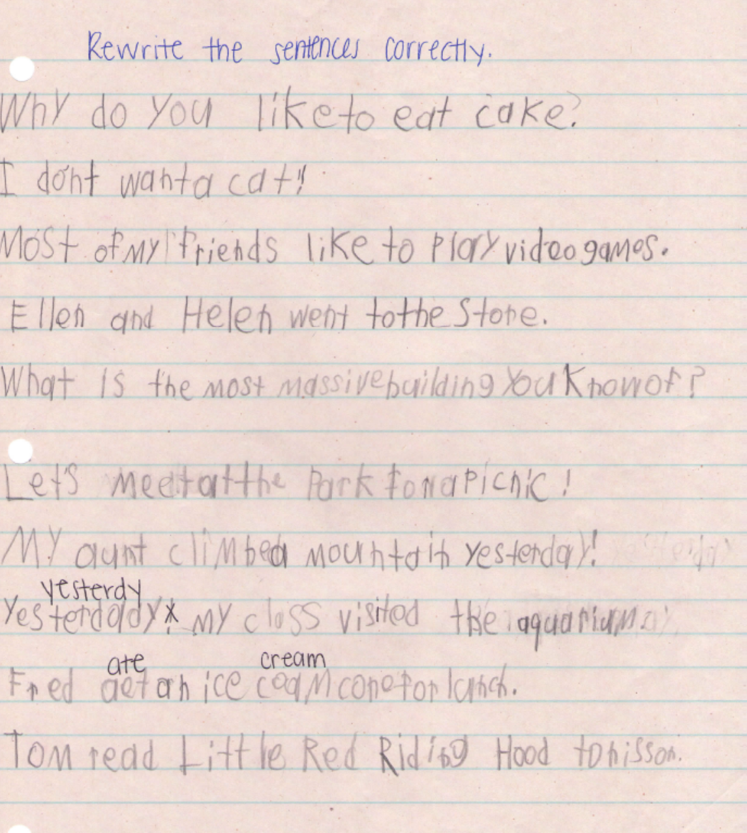

**Post Assessment**

|  |  |  |  |  |  |  |  |  |  |
| --- | --- | --- | --- | --- | --- | --- | --- | --- | --- |
| **Student:** | Student P |  |  |  |  |  |  |  |  |
| **Date of Lesson:** 4/22/2015 | | |  |  |  |  |  |  |  |
|  |  |  |  |  |  |  |  |  |  |
| This page will show evidence of growth compared to the writing samples and informal assessment that | | | | | | | | | |
| was done on Student P. | |  |  |  |  |  |  |  |  |
|  |  |  |  |  |  |  |  |  |  |
| **Prompt: Write 1 paragraph (at least 4 sentences) about a vacation to Six Flags. Remember capital** | | | | | | | | | |
| **letters, spaces between words, and punctuation at the end!** | | | | | |  |  |  |  |
|  |  |  |  |  |  |  |  |  |  |
| At Six Flags they have big roller coastars. They have a roller coastar Named Batman. On the ried | | | | | | | | | |
| on the ried is the Batman sembl. It staets out slow then goes fast. For vacation I wate to ried this ried. | | | | | | | | | |
|  |  |  |  |  |  |  |  |  |  |
| **Corrected Version:** | |  |  |  |  |  |  |  |  |
| At Six Flags, they have big roller coasters. They have a roller coaster named Batman. On the ride is the | | | | | | | | | |
| Batman symbol. It starts out slow, then goes fast. For vacation, I want to ride this ride. | | | | | | | | |  |





**Report**

Throughout the semester, Student P made a great amount of progress in his reading and writing. In January, he was reading at a level N on the Fountas and Pinnell book leveling system and now he is reading at a level P. Although he has made progress in his reading, Student P’s instructional reading level is still at a third grade level. I believe that Student P’s reading level is highly influenced by the amount of sleeping he does during the school day. In a given 30 minute time period, Student P is typically prompted to wake up 6 times by the teacher or the students sitting around him. He forgets what he was reading or starts reading at a random spot in the story once he wakes up.

Student P’s writing in January was almost illegible. He did not use capitalization or punctuation in his sentences. His writing consisted of random capital letters and punctuation marks, only at the end of a paragraph. He spelled words with haphazard letter combinations and would often misspell one word two or three different ways within the same paragraph. When he wrote paragraphs, Student P did not use a pattern with the topics of his sentences. He lacked sentence fluency and there usually was no main idea to his stories.

When working with Student P, I stressed sounding words out before writing them down and moving your pencil over one finger space before writing the next word. Student P was acceptant of sounding out his words before writing but did not want to put full finger spaces between words because he said it would take too long to write his sentences. With the little bit of space he did place between words and his progress in spelling, his writing has become much easier to read. Student P’s extreme lack of energy during the school day led me to work with him on strategies for staying awake. We practiced stretching and getting up to move around when he felt he was going to fall asleep. During our one on one tutoring, I always had Student P take breaks between sentences in order to keep his attention.

After three months of working one on one with Student P, he was eager to work with me. He was always highly engaged and only fell asleep once during our lessons. When Student P fell asleep, I postponed the lesson to a later day when it would be more successful and beneficial for him. In the one on one sessions with Student P, he demonstrated progress in the area of writing sentences. Student P is now using capital letters at the beginning of all of his sentences and noticing his own error if the capital letter is forgotten. Punctuation is not as stressful for Student P anymore; he ends each of his sentences when writing by saying “period.” Although Student P still sleeps through most of the writing block each day, the classroom teacher has noticed progress in his capitalization, punctuation, and legible sentences. The teacher noted that he can tell where Student P’s sentences begin and end. Throughout the semester, Student P noticed his own progress and declared himself a “sentence genius.”

I think Student P would benefit from one on one time with a para each day. He strives to please the person he is working with and the para could work with Student P on all of the academic areas that he is struggling in. Student P would also benefit from a nap time each day. At least once a week, Student P is so exhausted that he does not function or participate throughout most of the school day. If he was given 20 to 30 minutes each day to nap either in the morning or after lunch, Student P would have more energy and be more willing to work and learn in the classroom. Student P is a student who is bright and highly capable of learning when given the support and resources necessary to overcome his tiredness.

**Analysis and Reflection**

Student P is not the only person who made progress throughout the semester. I learned about my strengths and weaknesses when planning and implementing lessons with individual students. Once I identified the areas that I needed to work on Student P with, it was difficult to decide what activities to incorporate. Teaching the lesson was much easier than planning the lesson and I learned how detailed lesson plans need to be if they are to be effective.

A big struggle for me was learning how to keep Student P awake. At first, I had Student P get his exercise ball when he felt tired, but because he hates the ball, he would become reluctant to work with me. I had to think of other strategies to use in order to keep him energized and attentive. I also learned how important it is to build a relationship with the students that I am working with. Student P loved learning about me and was always striving to please me with his work. At the end of my time working with Student P, he asked if I was going to come back and work with him next year. I was happy that I had built a trusting relationship with Student P and had helped him to become confident in his own learning.

If I could change anything about my experience with Student P, it would be choosing to work in the hallway earlier in the semester. Student P had a better attention span and showed more progress when he was removed from the classroom. I think Student P is worried about what students will think about his work and likes to be secluded. Often, at the end of my time working with Student P, I would let him nap for five or ten minutes in order to become more energized before going back into the classroom. Overall, I am proud of myself and Student P for the success we made throughout this semester.